

User Manual
Desk Management Module
www.flowhcm.com



Table of Contents
Desk Management Setup 2
Manage Room 3
Manage Floor 4
Desk Request 5
Desk Settings 7
Office 8
Floor 9
Room 10

Desk Management Setup

- Navigate to Organization Tab
- Click on Constant Form and search Manage Room Tab
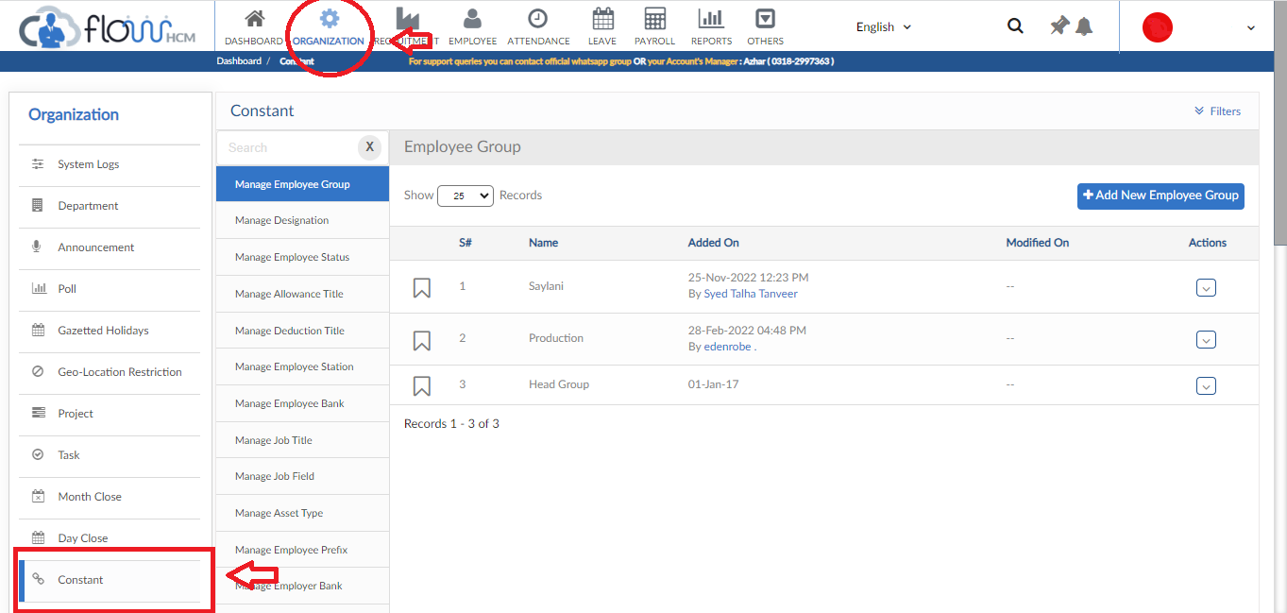

Manage Room
- Click on Add New Room button, pop up will be visible
- Insert Room title and click save button
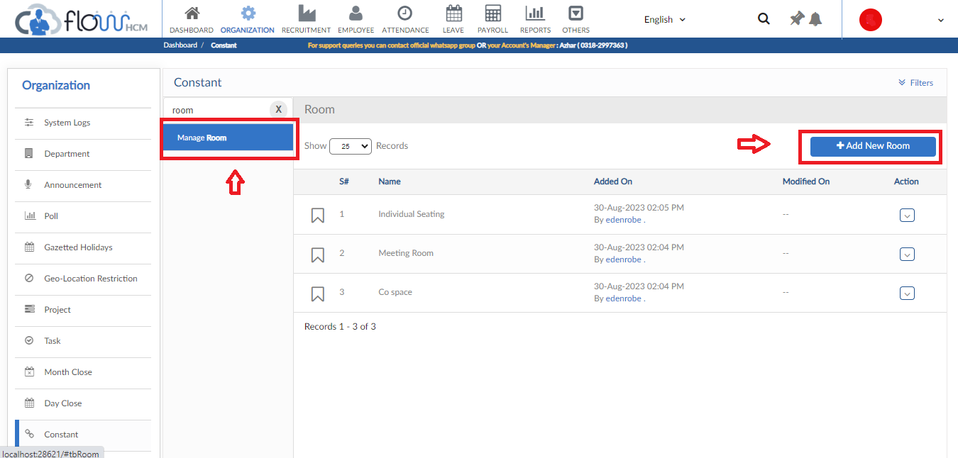
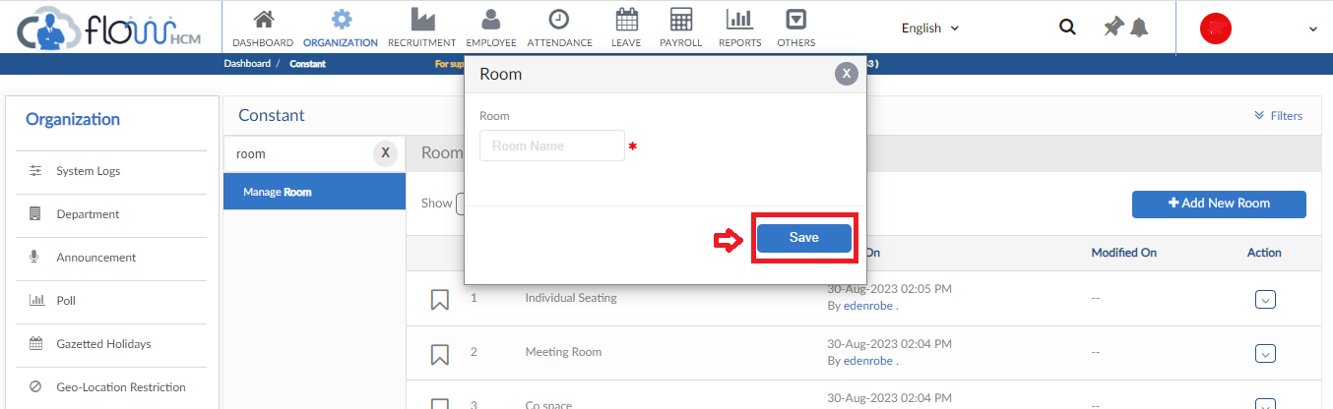

Manage Floor
- In Constant Form search Manage Floor Tab
- Then click on Add New Floor button
- Insert Floor title and click save button
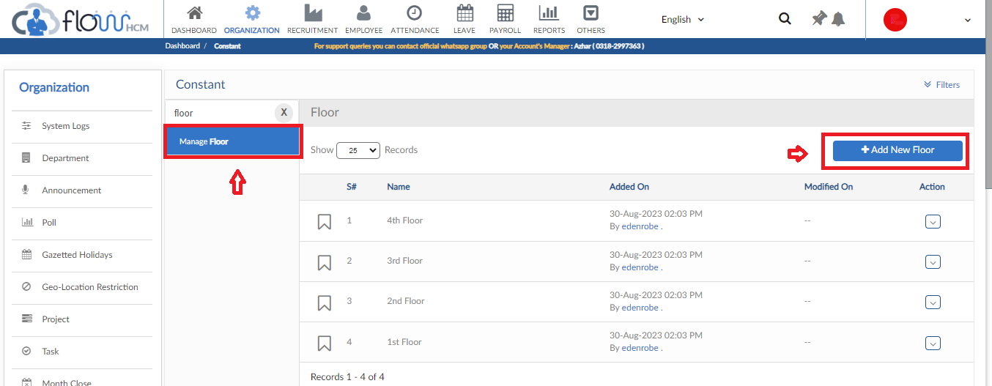
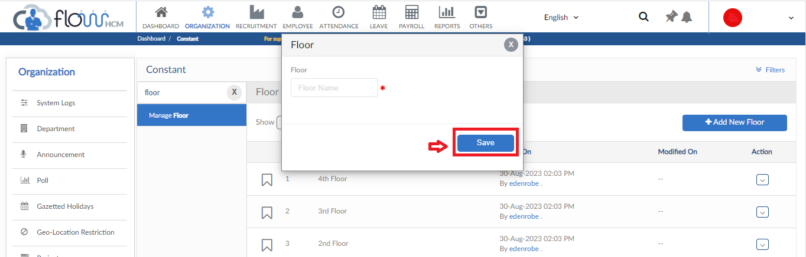

Desk Request

- To add Desk Request, click on Add New Request button
- Fill out the information (Employee, Office, Floor, Room and Dates) to see the availability of seats in that particular office
- Enter reason for request and then click on submit button
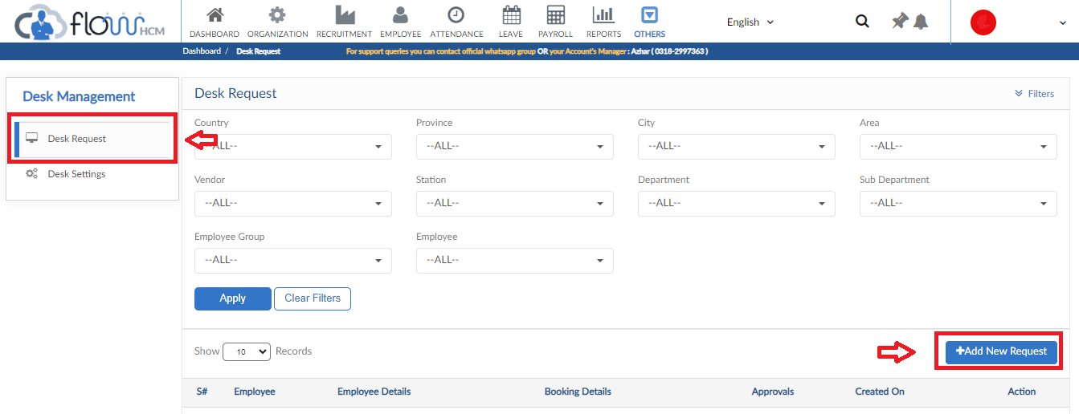
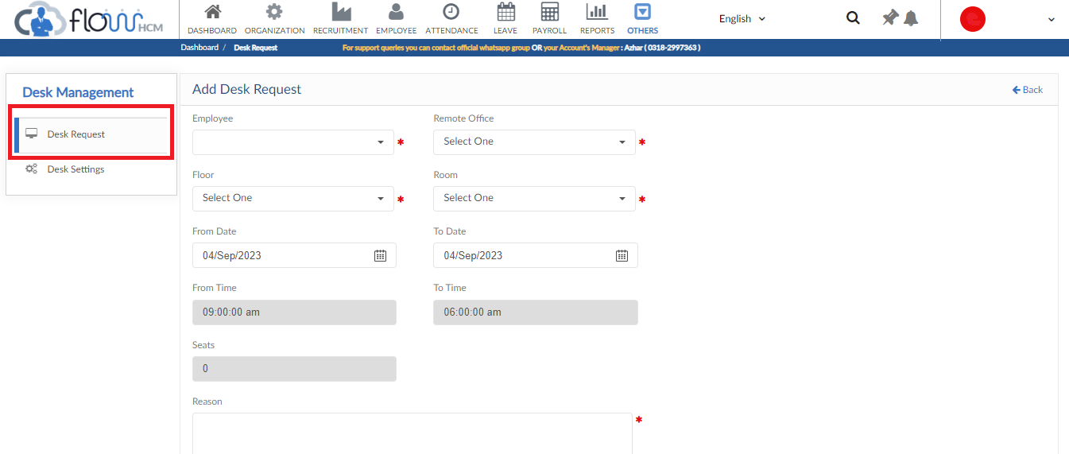

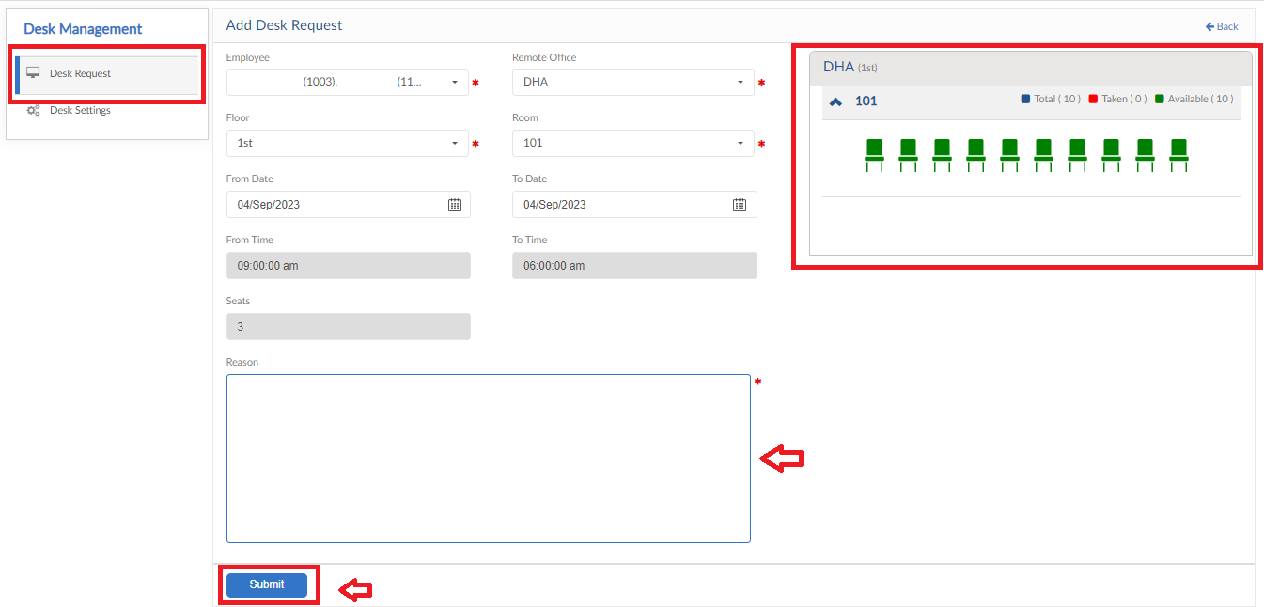

Desk Settings

- Click on Desk settings form
- That consist of multiple forms to setup the requisitions
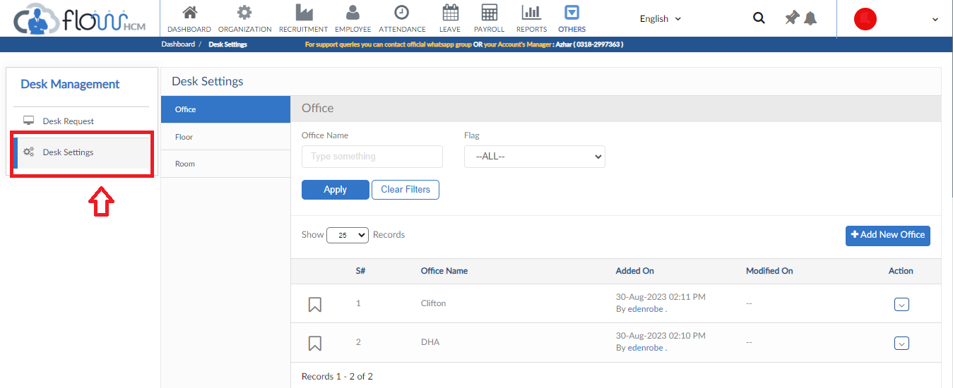

Office
- Click on Add New Floor button, pop up will be visible
- Enter required details for office and then click save button
- Longitude, Latitude and Radius of office will used incase of user marks attendance from mobile
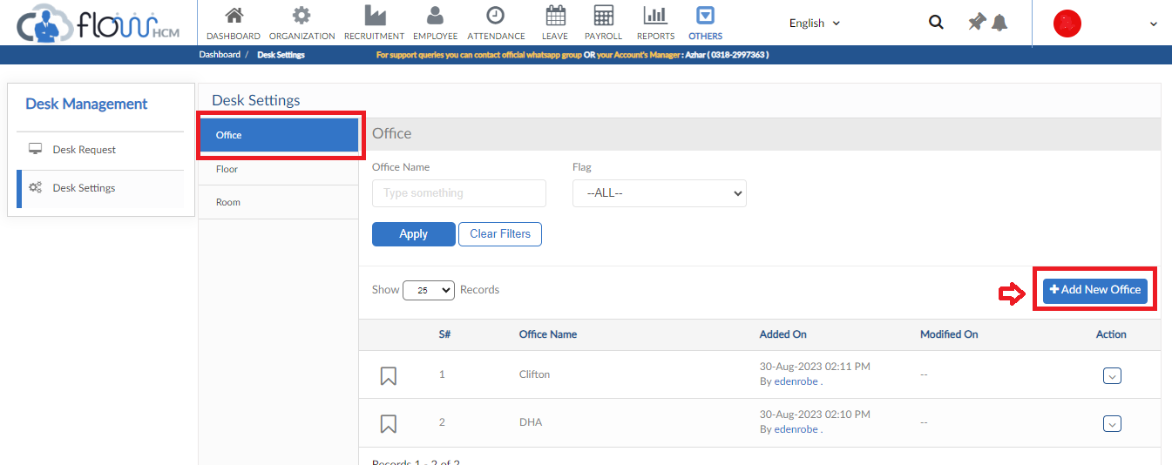
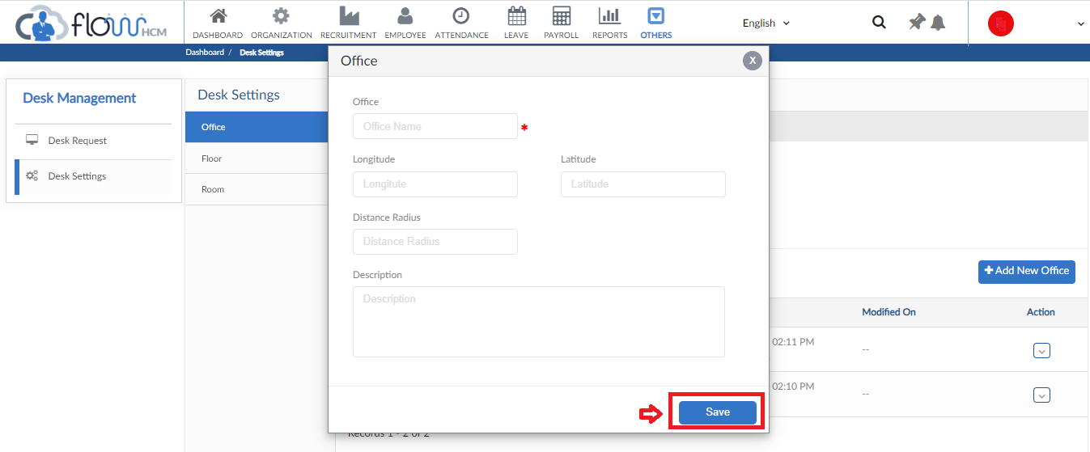

Floor
- Click on Add New Floor button, pop up will be visible
- Select details of Room from dropdowns and then click save button
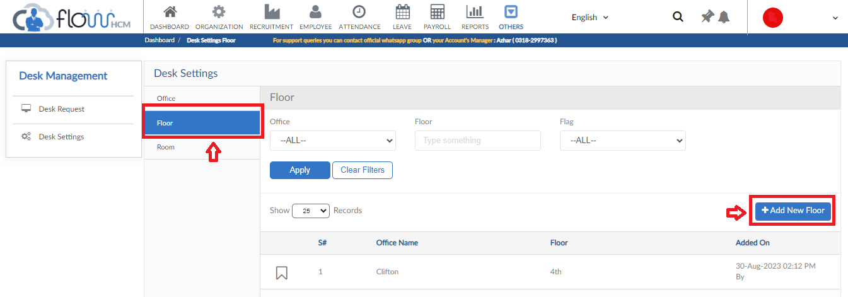
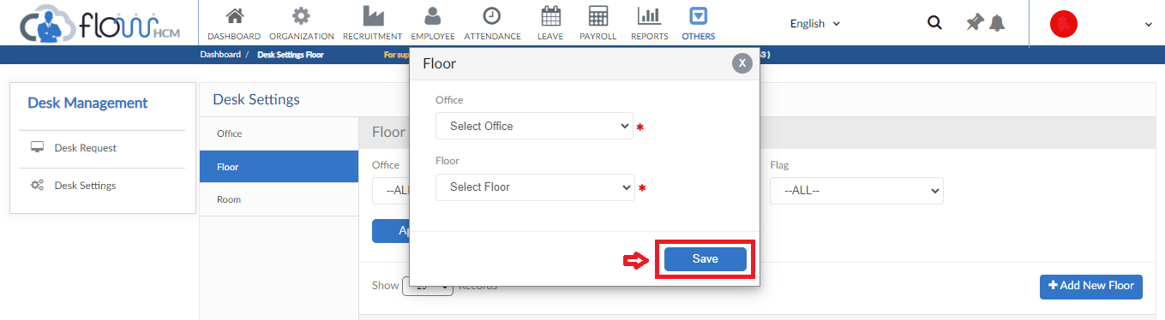

Room
- Click on Add New Room button, pop up will be visible
- Add details of Room and click save button
